Final Report of Aircraft Design

for specific delivery purpose

Team members

Qi Zeng, Master, team leader, main presenter, work of some calculation

Hongru Wang, Master, delivery system design, work of some calculation

Dian Liu, Master, weight analysis, work of some calculation

Peiwen Yang, Master, model design, work of some calculation

Requirement

Conceptual design project

A company based in Virginia decided to build propeller airplanes to airdrop packages directly to the customers in Richmond, VA on a trial basis. The airplane will take-off from DCA and will fly into airspace of Richmond, VA and deliver packages around Richmond and fly back to DCA. Put together a conceptual design with total life time cost for acquisition of 20 airplanes.

Crew: 3 (pilot, copilot, One technician to handle deliveries)

Each crew member’s weight is 150 lbs. Let each crew member be allowed to carry one small suitcase not weighing more than 10 lbs each.

Payload:

20 dell desktop computers (<http://www.dell.com/us/business/p/latitude-e5570-laptop/pd?ref=PD_Family>). Each computer need to be delivered to 20 customers backyards in the following places (assume that one customer lives in each of these places).

1. Henrico
2. Richmond
3. Wyndham
4. Goochland
5. Moseley
6. Chesterfield
7. Bensley
8. Mechanicsville
9. Hopewell
10. New Kent
11. West Point
12. King William
13. Powhatan
14. Jetersville
15. Chester
16. Petersburg
17. Charles City
18. Prince George
19. Bon Air
20. Glen Allen

They can be dropped gently in the customers’ backyard by one of the following ways

1. Using drones (you need to buy them) and the drones will be returned later to the company within 15 days of the delivery. You need to calculate cost of the drones. You do not have to design drones. Need to factor in cost of returning. How to recover the cost if they are not returned?
2. GPS guided package covers with parachutes (you need to buy them). The GPS covers will have to be returned within 15 days of the delivery. You need to calculate cost of the GPS guided packages. You do not have to design GPS guided packages. Need to factor in cost of returning. How to recover the cost if they are not returned?
3. Other innovative means. You need to buy them and should be returned to the company within 15 days of delivery. Need to factor in cost of returning. How to recover the cost if they are not returned?

The design involves not only (a) Design of the propeller Airplane but also (b) package delivery system

Design of the airplane:

Maximum cruise speed 270 miles/hr

Maximum operating altitude 25,000 ft

Piston Engine

Maximum Range 1000 nm

Take off distance not to exceed 2000 ft

Take off Ground roll not to exceed 1400 ft

Landing distance not to exceed 3000ft

Landing Ground roll not to exceed 1400 ft

Stall Speed not less than 69 miles/hr

Maximum Climb rate not to be less than 1400 ft/min

Should be capable of loitering (endurance) for 4 hours @ 10,000 ft altitude.

Number of Test aircraft 1

Estimate

1. the cost of the production of 20 (does not include test aircraft) airplanes
2. Cost of package system such as drones, GPS envelopes with parachutes and other associated equipments, used for dropping 20 computers by each of the airplane.
3. Cost of the 20 computers.

Mission:

.

Warm up & take off from DC

0 Warmup

2 ((DCA)

3

1

Climb

2-3 Cruise from DCA to Richmond area (25,000 ft)

3-4 Loiter Richmond area (10,000ft, 4 hrs )

Deliver packages

Land at DCA

4

7

Descend

6

5

4-5 Cruise from Richmond to DCA (25,000 ft)

TOGW by Conceptual sketch method

As discussed in Report #1.

According to the requirements, we consider a single piston engine propeller aircraft with these basic characteristics below.

AR=10,

Swet/Sref =5.0,

⇒ Wetted Aspect ratio=AR/ (Swet/Sref )=10/5.0=2

⇒ for fixed-gear propeller aircraft, L/Dmax=12.8

v=270 mph=396 ft/s

Ct=CBHP*v/(550*ηp)=0.0001

R=92miles =(considering some detour in the cruise)=500000 ft

1. Firstly, consider the specific mission

From historic data, 0 – 1: W1/W0= 0.970

1 – 2: W2/W1= 0.985

6– 7: W7/W6=0.995

The cruise weight fraction is calculated as below,

W3/W2= W5/W4 =exp(-RCt/(L/D))=0.990

The loiter weight fraction is calculated as below,

W4/W3=exp(-EC/(L/D*0.866)=0.878

⇒W6/W0=0.970*0.985*0.990*0.878*0.990*0.995=0.818

Ignoring the weight loss of packages and delivery drones and considering 6% fuel reserve, Wf/W0=1.06*(1-0.818)=0.193

In order to get We/W0, we use A=1.51, C=-0.10 for twin propeller general aviation aircraft.

We/W0 =1.51*[W0-0.10 ]*1.00

Then calculating the final weight including crew and payload.

W0=(Wcrew+Wpayload)/ (1-(Wf/W0)-(We/W0))

⇒ W0=(480+17*20)/(1-0.193-1.51*W0-0.10)

Using the same MATLAB code as that in assignments, we can get:

W0=5028 lb

Tickness ratios of Wing Root and tip airfoil, Sketch of Root and Tip airfoils

Root: Boeing 737 Root Airfoil (b737a-il), CLmax=1.5237 for high Reynolds number.

Max thickness: 0.154

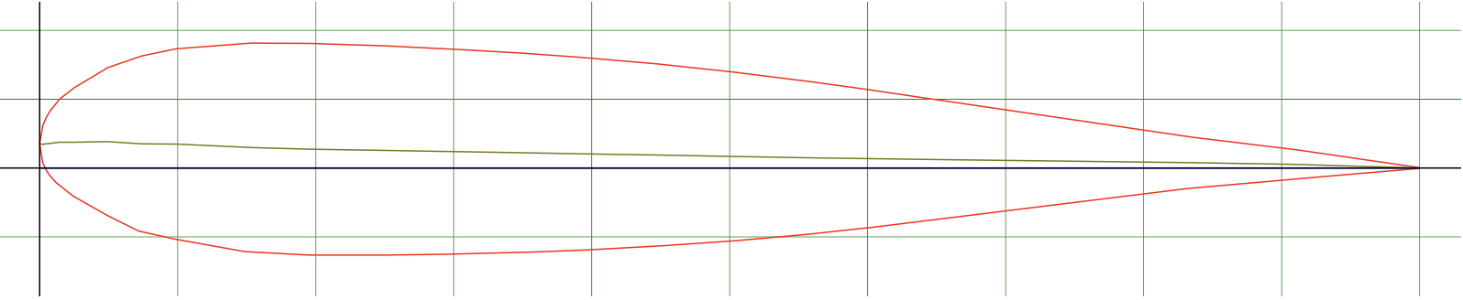

Tip: Boeing 737 Outboard Airfoil (b737d-il), CLmax=1.3518 for high Reynolds number.

Max thickness: 0.108

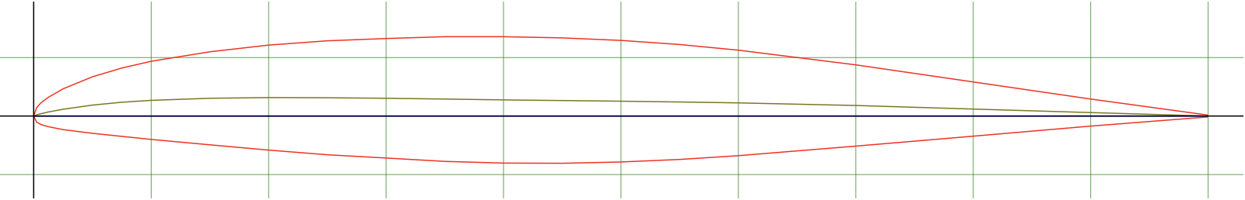

Lift coeficient of cruise root and tip airfoils for 5 deg

Root: Cl=0.72 at 5 deg

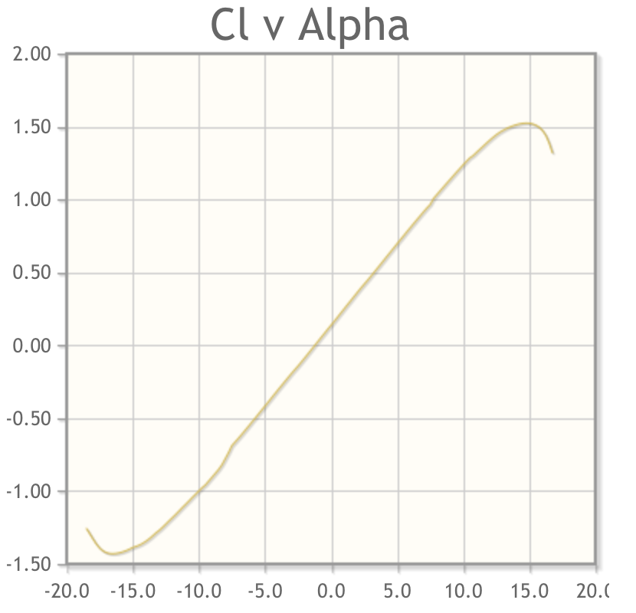

tip: Cl=0.72 at 5 deg

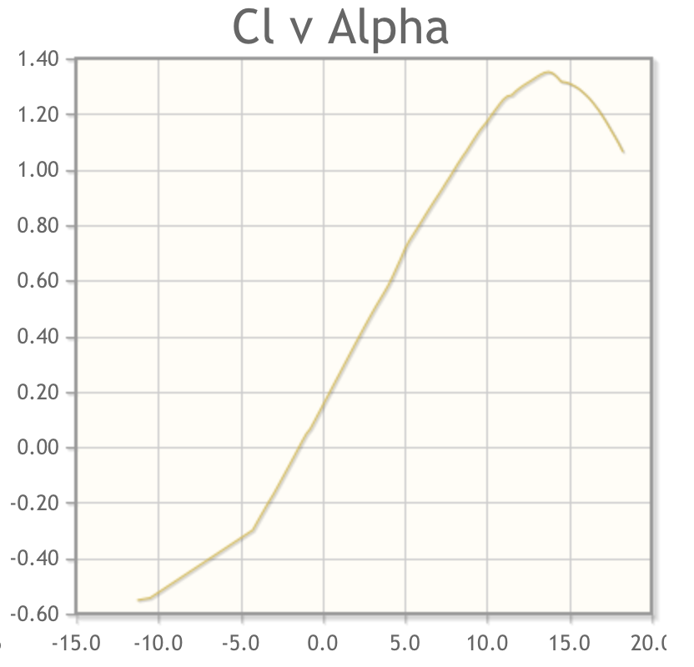

Lift coefficient of cruise wing at 5 deg by the method of averaging using lift coefficient of root at 5 degrees and tip airfoil at 5 deg

Cl=(0.72+0.72)/2=0.72

Wing Geometry details:

Aspect Ratio

AR=10 from historic data.

Reference Wing Area

$δ=0→S_{ref}=S_{exposed}=277.02 {ft}^{2}$

Root Chord, Tip Chord and Taper Ratio

As calculated above, S=277.02 ft2. From historic data, we choose λ=0.7 for this propeller general aviation aircraft. Croot=2*S/(b*(1+ λ))=6.19 ft. Ctip=6.19*0.7=4.33 ft.

Span

As calculated after, W/S=18.15 and refined W0=8402 lb, wing span b=sqrt(A*S)=sqrt(A* W0/(W/S))=52.63 ft.

Leading edge sweep

Due to the max Mach number=0.39, we can pick the sweep angle to be 2 degrees from figure 4.20 in the textbook.

Quarter chord line sweep angle

Since the leading edge sweep is 2 deg, according to calculation by trigonometric functions, the quarter chord line sweep is 0.99 deg.

Trailing edge sweep

Since the leading edge sweep is 2 deg, according to calculation by trigonometric functions, the trailing edge sweep is -2.05 deg.

Mean aerodynamic chord

Cbar=2/3* Croot*(1+ λ+ λ2)/ (1+ λ)=5.32 ft.

Wing Twist

For initial design purposes, historical data should be used. Typically, 3 deg of twist provides adequate stall characteristics.

Wing Incidence

Wing incidence is typically 1 deg for transport aircraft and 2 deg for general aviation. Considering this aircraft has more characteristics as transport aircraft, the wing incidence is chosen to be 1 deg.

Wing dihedral

From table 4.2, the dihedral must be chosen so that it is between 0 and 2. We will choose it to be 0.

Details of Ribs, Wing Box and Spars with sketch

See appendix 1.

Wing leading edge x, z location

x location: at 30% of fuselage.

z location: high-wing, at the upmost of fuselage.

Wing location with respect to fuselage

We choose high wing location because it can provide much easier cargo loading and dropping solutions. And it also minimizes the influence of propellers when dropping drones from a rear door.

Wing tip treatment

We choose upswept wing tips in order to decrease some lift induced drag to provide better economical performance.

Details (chord, span, leading edge sweep etc) of Flaps, Ailerons, Spoiler

Chord of ailerons and flaps are 15 to 25% of the wing chord. We choose to use 20% which is the preferred amount for Cessna planes.

$C_{aileron}=20\%C_{wing}=0.2×6.19=1.238 ft$

$C_{flap}=C_{aileron}=C_{spoiler}1.238 ft$

We also choose flap and spoiler span to be 50% of wing span and aileron 20%

bflap= bspoiler=26*0.5=13 ft each side

baileron=26*0.2=5.2 ft each side

Tail details: Type of Tail, Tail positioning

The tail assembly will be placed in a T-tail formation placed on the aft most part of the fuselage.

Tail volume coefficients

From table 6.4 in the textbook, CHT=0.8, CVT=0.07 for general aviation twin engine.

Details (chord, span, leading edge sweep etc ) of Horizontal tail

As calculated above, S=277.02 ft2 and b=52.63 ft. LHT= LVT= 0.6*38.3=23.0 ft

SHT=CHT*Cbar*SW/LHT=51.26 ft2.

Since wing AR=10, we get ARHT=5.5 from historic data.

As ARHT=bHT2/SHT, we can get bHT=16.79 ft.

With the same λ as wing, Croot=2*S/b*(1+λ)=3.592 ft, Ctip=2.514 ft.

leading edge sweep same as wing 2 deg.

Vertical tail

SVT=CVT*bW*SW/LVT=44.37 ft2

Since wing AR=10, we get ARHT=2.0 from historic data.

As ARVT=bVT2/SVT, we can get bVT=9.42 ft.

Croot=5.54 ft, Ctip=3.89 ft.

Stabilizer, Rudder

$C_{elevator}=30\%C_{tail}=0.3×3.592=1.078 ft$

$C_{rudder}=C_{elevator}=30\%C_{tail}=1.662 ft$

$b_{rudder}=b_{elevator}=80\%C_{tail}=2.87 ft$

Fuselage details: Fineness ratio, Length

From the table 6.3 in the textbook, general aviation twin engine aircraft will have a=0.86 and c=0.42, fuselage length= aW0c=38.3 ft.

Wetted Area of wing

Based on the already calculated t/c we have:

$\frac{t}{c}=0.15→\frac{t}{c}>0.05→S_{wet}=S_{exposed}(1.977+0.52\left(\frac{t}{c}\right))$

$δ=0→S_{ref}=S_{exposed}=277.02 {ft}^{2}$

$S_{wet}=277.02\left(1.977+0.52\left(0.15\right)\right)=$ 569.3 ft2

Wetted Area of Fuselage

Fuselage: Atop=220 ft2 Aside=198.1 ft2

Wetted Area ~ 220*2+198.1*2=836.2 ft2

Wetted Area of tail

SVT+ SHT=95.63ft2,

196.5 ft2

Wetted volume of fuselage

Wetted volume ~ 3.4 (Atop) (Aside)/4L =967.2 ft3

Thrust to weight Ratio

For a general aviation varying with speed, P/W0=a Vmax C, hp/lb

(twin propellers), where a=0.036 and c=0.32.

Vmax =270 mph =234.6 kt. P/W=hp/W=0.206 or W/hp=4.85.

Wing Loading

The detailed calculations are discussed in Report #2. We choose the minimum W/S in all calculations. W/S=18.15.

Stall Speed

$V_{stall}={[\frac{2mg}{ρSC_{Lmax}}]}^{1/2}={=[2\left(\frac{W}{S}\right)/ρC_{Lmax}] }^{1/2}=108.5ft/s$ =74 mph

Refined TOGW

For this twin engine piston propeller general aviation aircraft, the indices are given as below.

a=-0.9, b=1.36, c1=-0.1, c2=0.08, c3=0.45, c4=0.05, c5=0.2

Refined We/W0=0.76.

Refined (L/D)cruise=17.72 and (L/D)loiter=17.70

Then recalculate the mission with refined L/D.

We will get W3/W2= W5/W4=0.994 and W4/W3=0.922.

Finally, W6/W0=0.866 and refined W0=8402 lb

Load paths on fuselage and wing with sketches

See appendix 2.

Crew station details/ if it is uav give details of automatic control equipment

This is not designed to be a UAV. Since there are two pilots in the cockpit, 100” width is usually used. The fuselage is wide enough for the pilots and equipment inside cockpit. The overnose angle will be 5 degrees because it is a general aviation plane.

Design of the fuselage section for technicians

There are only one engineer needed for the mission. We will place two seats for other special occasion. The seats will be at the headmost of the pressurized cargo area. So no special fuselage will be applied at this section.

Optimization of route

As described below in package delivery section, we choose drone to have ability to fly up to 10 miles range. Also considering the loitering speed of the aircraft being very large comparing to the distance between customers, to be realistic, flying to the exact location is meaningless and not feasible. We choose to loiter around the delivery area.

Package disposal technology

The mission is to delivery 20 computers with weight 2.1 kg each. Since this is a very low payload requirement for delivery system, drones are preferred for efficiency and convenience rather than GPS guided parachutes. After searching the internet for both commercial drones and GPS guided parachutes, we find that GPS guided parachutes are more suitable for much heavier payload and difficult to return efficiently. The difficulty in returning will result in more equipment required for the same size of business. Although single drone is much more expensive than a GPS guided parachute, the whole operating costs will be quite similar. Therefore, it becomes much easier to use drones.

This system runs as described below.

* Drones with packages will be dropped from the loitering aircraft.
* Drones with an integrated dropping parachute system will start to fly after reaching a certain altitude near the ground.
* After delivering the packages in the yards of customers, the drones will continue to fly to a collecting position located near Richmond.
* When all drones collected, they will be sent back to DCA by a truck and get ready for the next service.

With the requirement that the drones need to be dropped from an aircraft at high altitude and payload more than 2.1 kg and the ability to fly to the collecting position, we decide to use a product from Prodrone Co., Ltd.. The Prodrone PD6-AW can perfectly fit all these requirements. More information can be find here. https://www.prodrone.jp/en/products/pd6-aw/

Landing gear

We choose Tricycle type as Landing gear, as shown in figure below. It has a flat cabin floor, which is good for packages placing.

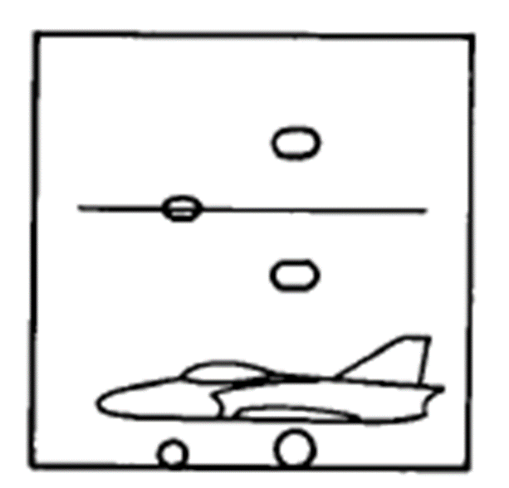

Since Wt=8406 lb, which is much less than 50000 lbs, one mean wheel/strut should be used. Tricycle landing gear geometry: tipback angle = 25 degrees, overturn angle = 54 degrees, strut travel = 7 degrees.

Tire sizing

During this phase, dynamic loads cannot be calculated.

Main tires carry 0.9*8406=7565 lb

Diameter= AWwB=1.51*75650.349=34.10”

Width=AWwB=0.715*75650.312=11.6”

Nose tires carry 0.1*8406=840.6 lb

Diameter= AWwB=1.51*840.60.349=15.83”

Width=AWwB=0.715*840.60.312=5.84”

Since this aircraft is larger than typical general aviation aircraft, extra high pressure type VII tire will be used.

Shock absorber

The oleo pneumatic shock strut, or “oleo,”, is the most common type of shock-absorbing gear in use today. The oleo combines a spring effect using compressed air with a damping effect using a piston that forces oil through a small hole (orifice).

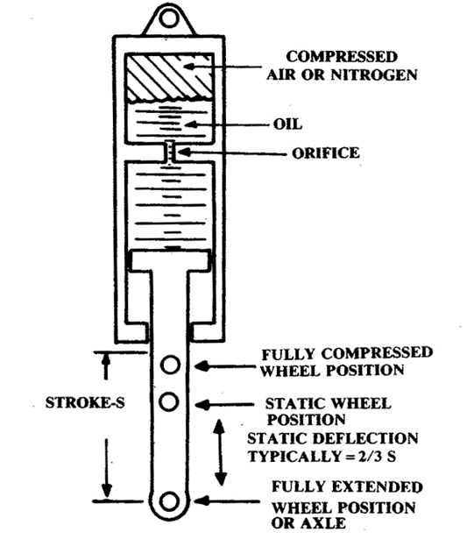

Gear retraction

Considering the high wing and fuselage choice, the gears will be retracted into a fuselage-podded space.

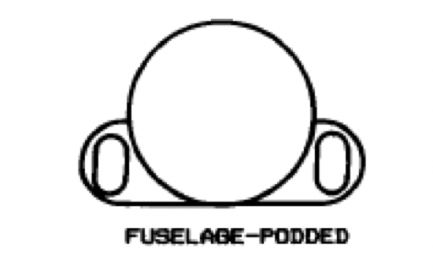

Aerodynamics:

Lift (coefficient) curve slope of wing

2πAR F

CLα= -------------------------------------------- (Sexposed/Sref) = 5.15

2+ [4+(AR2β2/η2)(1+(tan2Λmax,t/ β2))]1/2

Wing Loading by Shrenk's method

Planform c(y)=6.19[1-(y/26.315)(1-0.7)]=6.19[1-.0114y]=cp(y)

Elliptical chord c(y)=[4S/πb] [1-(2y/b)2](1/2) =(4*276.83/ ((π*52.63))* [1-(2y/52.63)2](1/2)

= 6.6971* [1-(y/26.315)2](1/2)=ce(y)

Load (y)=(1/2)*[cb(y)+ce(y)]=4.389-0.169y

Maximum lift coefficient calculation of cruise wing based on root and tip airfoils

B737a clmax=1.524

CLmax=1.524*0.9=1.372 (clean, no flaps)

B737d Clmax=1.352

CLmax=1.352*0.9=1.217 (clean, no flaps)

CLmax= (1.372+1.217)/2= 1.295

Maximum lift coefficient calculation of high lift wing based on root and tip airfoils with high lift at 10 deg

Sflapped/Sref=0.5

We choose to use slotted flap.

∆CLmax=0.9*1.3 (Sflapped/Sref)=0.585

CLmax=1.295+0.585=1.88

Drag by equivalent skin friction method

CD0=Cfe (Swet/Sref)=0.00617

Drag by component buildup method

Re=6.6*10^7

So we use turbulent flow for cf=0.455/[(log10Re)2.58 (1+0.144M2)0.65]=0.0022.

FF= [1+ {0.6/(X/C)max }(t/c) +100 (t/c)4] *[1.34 M0.18 (cos Λ1/4)] =0.2586

We have external store mounted on fuselage, high wing and T-tail. Their Qc are 1.5, 1.0, 1.05.

CD,L&P=5% for propeller aircraft from table 12.8.

CD0= [Σ (Cfc FFc Qc Swetc )/Sref] +CD misc +CD,L&P=0.05

Drag due to lift

We use Oswald span efficiency method to calculate drag due to lift. Since this is a normal aspect ratio and nearly straight-wing aircraft, from equation (12.48) in textbook,

e=1.78*(1-0.045*AR0.68 )-0.64=0.75

Piston engine integration details

Note: As claimed in the email and last presentation, we have to choose turbo prop engine rather than piston engine.

Engine location

We will be placing the engines in a tractor configuration. They will be placed on the high-wing leading edge.

Engine scaling

We will use fixed engine so the scaling is not needed. We choose P&W PT6A small engine.

Engine performance

At 10,000 ft:

$\left(\frac{ρ}{ρ_{0}}\right)=\frac{0.001756}{0.002377}=0.7378$

$\left(\frac{P}{P_{sealevel}}\right)=\left[\left(\frac{ρ}{ρ_{0}}\right)-\left({1-\left(ρ/{ρ_{0}}\right)}/{7.55}\right)\right]=\left[\left(0.7378\right)-\left({1-\left(0.7378\right)}/{7.55}\right)\right]=0.7030$

At 25,000 ft:

$\left(\frac{ρ}{ρ_{0}}\right)=\frac{0.001066}{0.002377}=0.4484$

$$\left(\frac{P}{P_{sealevel}}\right)=\left[\left(\frac{ρ}{ρ_{0}}\right)-\left({1-\left(ρ/{ρ_{0}}\right)}/{7.55}\right)\right]=\left[\left(0.4484\right)-\left({1-\left(0.4484\right)}/{7.55}\right)\right]=0.3753$$

Fuel lines

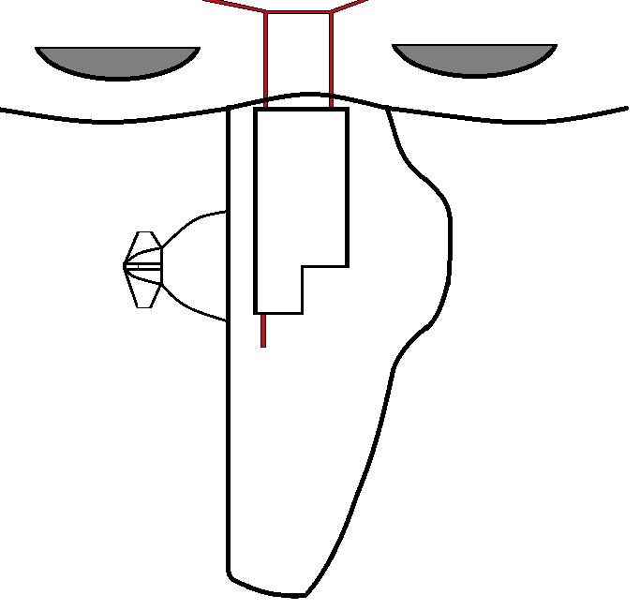

Fuel location

The fuel will be stored in the wings. If additional storage is necessary, it will be placed in

attachable fuel tanks inside fuselage-podded space for landing gears.

Sketch of the fuel tanks

See appendix 1.

Structure and Loads: Basic V-n diagram

$$m=8406 Ib, S=277 ft, C_{Lmax}=1.295 ,AR=10, ρ=0.00238, V_{C}=270mph=396{ft}/s$$

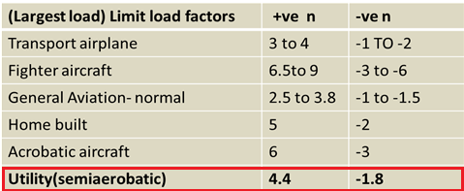

We choose $n_{pos}=4.4 { n}_{neg}=-1.8$,which decide point F and G.

Vstall=108.5 ft/s implies point A (108.5,1).

$N=\frac{L}{W}=\frac{0.5ρV^{2}SC_{Lmax}}{W}→4.4=1.16×{10}^{-4}V^{2}$, $V=195{ft}/s$,

which gives us point B ($195$, 4.4).

$-N=-\frac{L}{W}=\frac{0.5ρV^{2}SC_{Lmax}}{W}→-1.8=-1.16×{10}^{-4}V^{2}→V=124 ft/s$,

which gives us point J (124,-1.8).

$-N=-\frac{L}{W}=\frac{0.5ρV^{2}SC_{Lmax}}{W}→-1=-1.16×{10}^{-4}V^{2}→V=93ft/s$,

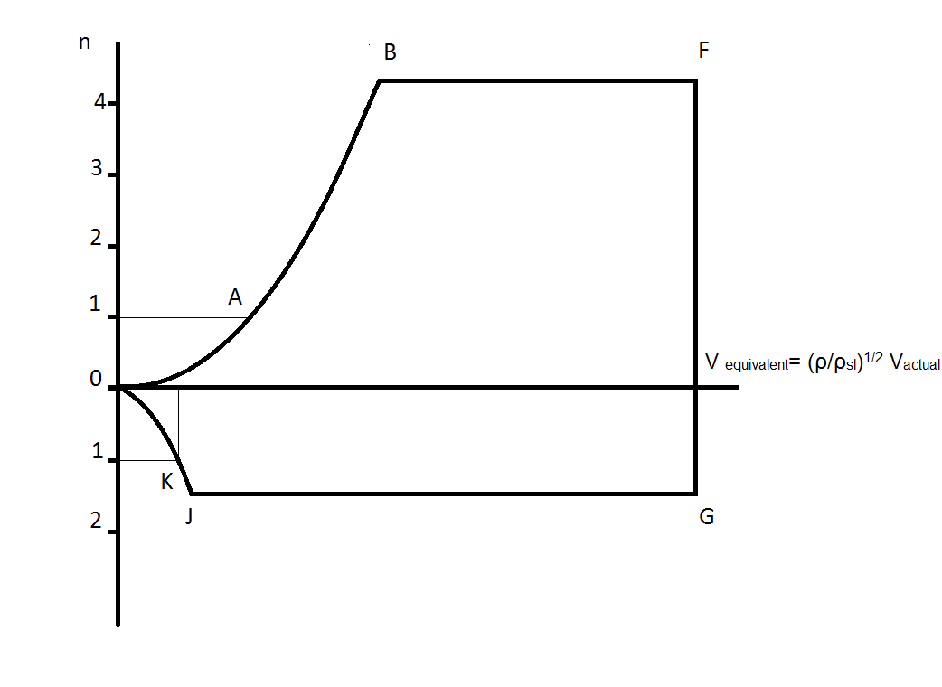which gives us K($93$, -1).

Approximate group weight method

Due to the high performance and the design of this aircraft, like the airfoil choice, retractable landing gear and high performance engine choice, we define it as transport aircraft.

Using the wetted area calculated before, we can get

Empty weight=4181+525.8+114.8+2770+o(w)=7591 lb

TOGW=7591/0.76=9988 lb

Statistical group weight method

From Equations 15.46-15.59, we can get:

Wwing=965.1 lb

Whorizontal tail=155.1 lb

Wvertical tail=157.8 lb

Wfuselage=850.2 lb

Wmain landing gear=205.9 lb

Wnose landing gear=41.2 lb

Winstalled engine=1050.9 lb

Wfuel system=1065.2 lb

Wflight controls=29.1 lb

Whydraulics=0.18 lb

Weletrical=619.6 lb

Wavionics=1235 lb

Wair conditioning and anti-ice=26.8 lb

Whandling gear=2.52 lb

Wfurnishings=17.82 lb

W=6422.1 lb

TOGW=6422.1/0.76=8450 lb

Final comparisons of TOGW

Conceptual: W=5028 lb

Refined: W=8406 lb

Approximate group weight method: W=9988 lb

Statistical group weight method: W=8450 lb

Performance: Maximum Range (R)

R=(550ηP/CBHP)(L/D) ln(Wi/Wf) = 10834736 ft = 2052 miles

Maximum Endurance (E)

E=(L/D)*(550ηP/CBHPV)ln(Wi/Wf)= 123126 s = 34.2 h

TO distance (detailed method)

KT=(T/W)- μ = 0.15

KA=(ρ/2(W/S))(μCL-CD0-KCL2) = 0.000007

Sg = 918 ft

Sr = 2*VTO = 2*98=196 ft

Ground rolling distance=918+196=1114 ft <1400 ft as required.

Str = R[(T/W)-(1/L/D)] = 278 ft

Sc = (50-htr)/tan(Yclimb) = 321 ft

Total TO distance=1114+278+321=1713 ft < 2000 ft as required.

Landing distance (detailed method)

Hf = 0.24(Vstall^2)(1-cos(3)) = 3.452 ft

Sa = (50-Hf)/tan(3) = 888.2 ft

Sf = (0.24(Vstall^2)-Hf)tan(3) = 146.5ft

Sfr = 2Vtd = 2*1.15*VStall = 248.4 ft

Sb = 898.3 ft

Landing ground roll = 1146.7ft <1600ft as required.

Total Landing Distance = 2181.4ft < 3000ft as required

Cost Analysis

RDT&E + Flyaway Costs:

According to all the data obtained above, we have:

Engineering Hours = HE = 49746797

Tooling Hours = HT = 241953

Manufacturing Hours = HM = 433902

Quality Control Hours = HQ = 0.076

Development-support Cost = CD = 19869130

Flight Test Cost = CF = 6401670

Manufacturing Materials Cost = CM = 22.1(4367.33).921(234.63).621(10).799 = 1515598

Cost of Engine = Ceng = 200000*2 ( generally the price for a P&W PT6A engine)

Cost of Avionics = Cavionics = 20000

RDT&E + flyaway costs = HERE + HTRT + HMRM + HQRQ + CD + CF + CM + CengNeng + Cavionics

= $130,919,985

Cost of 1 airplane and 20 airplanes

Cost of 1 aircraft: $130,919,985

Cost of 20 aircrafts:

Engineering Hours = HE = 942615

Tooling Hours = HT = 531989

Manufacturing Hours = HM = 930770

Quality Control Hours = HQ = 0.076

Development-support Cost = CD = 19869130

Flight Test Cost = CF = 6401670

Manufacturing Materials Cost = CM = 16599965

Cost of Engine = Ceng = 200000*2*20 ( generally the price for a P&W PT6A engine)

Cost of Avionics = Cavionics = 20000*20

Cost of 20 aircrafts= $ 247,097,036

Cost per pound of airplane= (cost of 1 airplane)/(takeoff weight- weight of crew- weight of packages)

$130,919,985 for 1 aircraft, weight=8450-480-17*20=7630 lb

cost per pound=$ 17,158.58

Three views of the airplane

Conceptual:

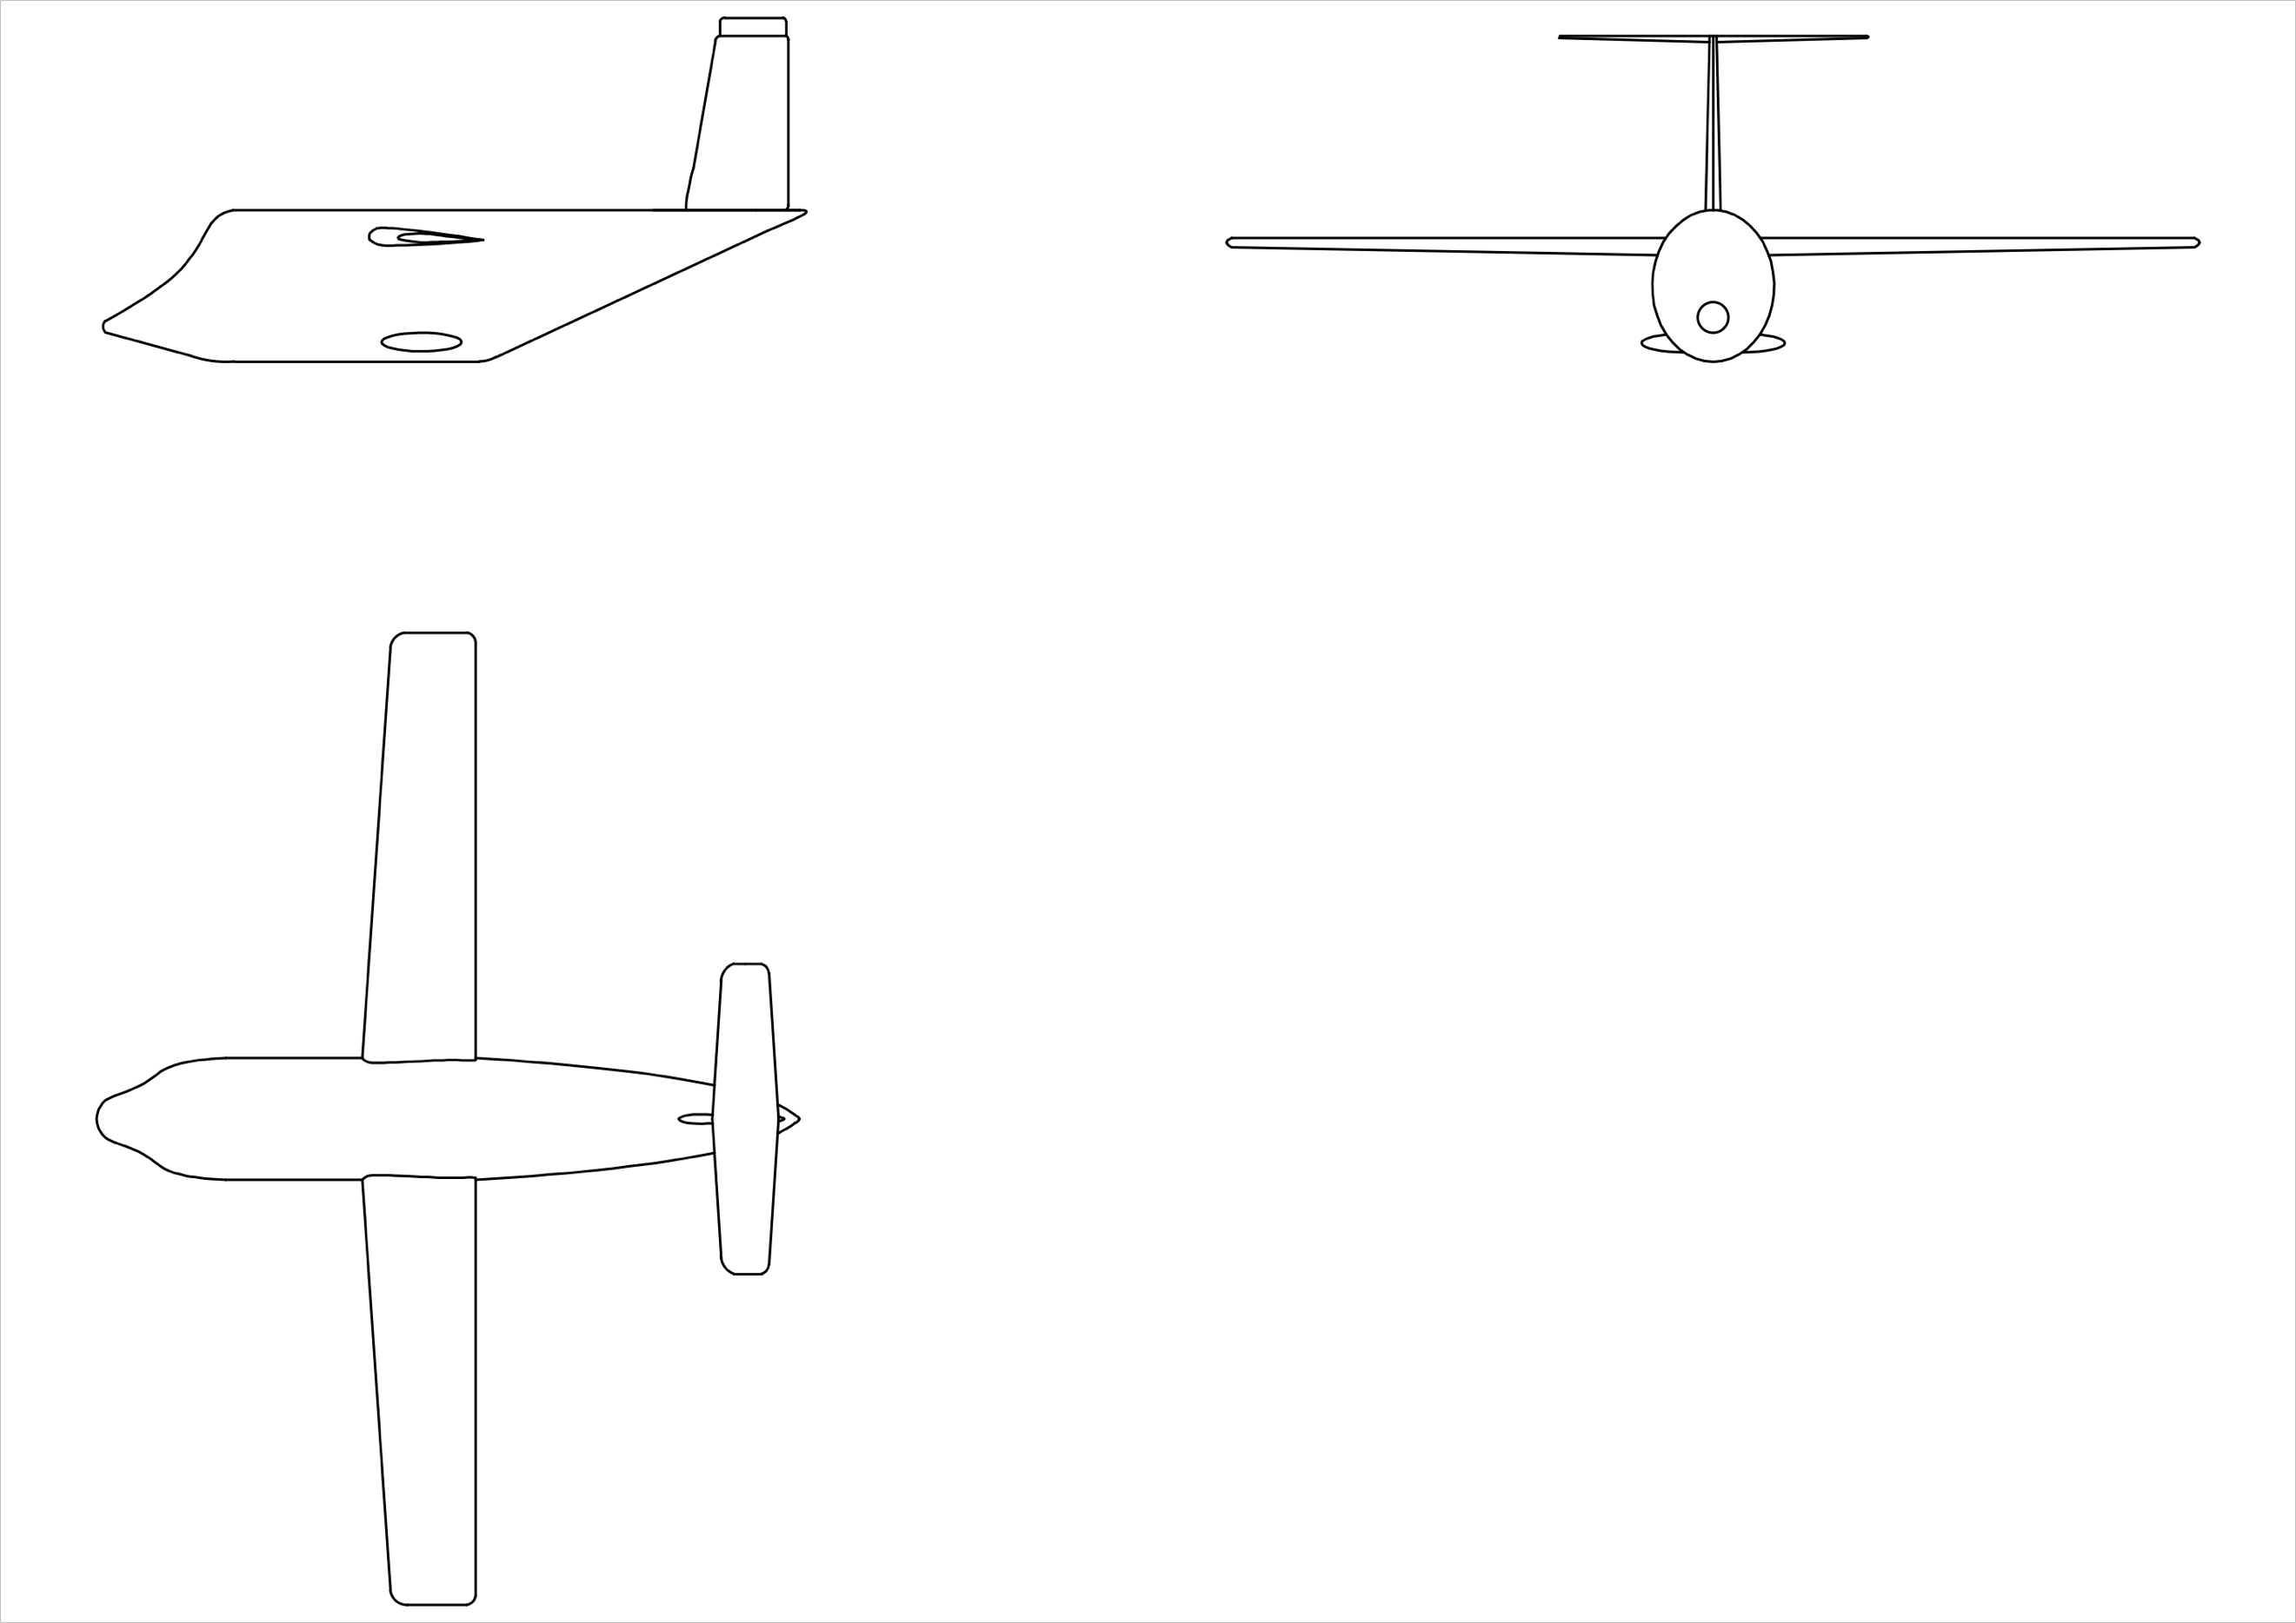

Detailed from modelling:

